HOOK COMMUNITY COUNCIL
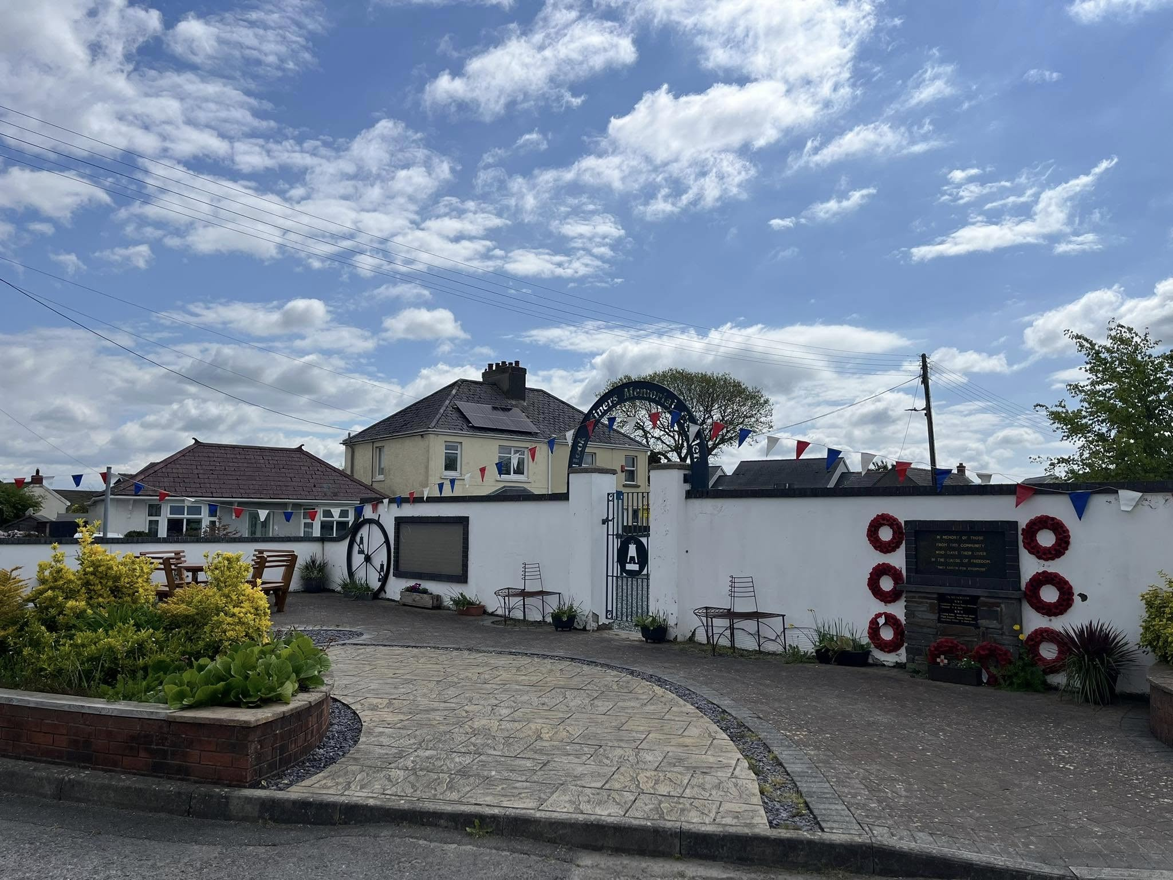

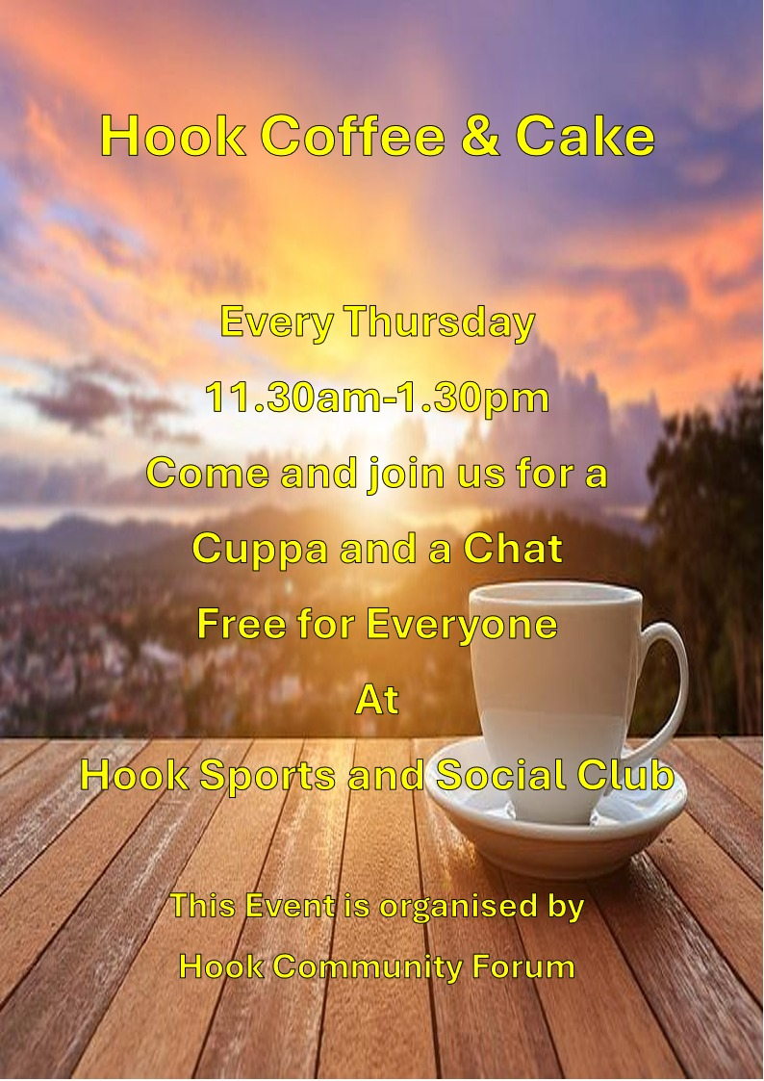
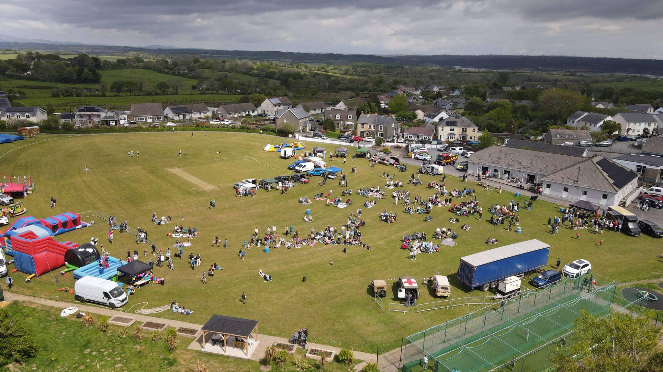

Are you passionate about Hook?
Do you want to make a difference?
Would you like to be involved?
Have you seen what we have been doing?
Do you want to represent the views of local people?
Do you have the time and expertise that can benefit our Community?

If the answer to any of the above is YES, make a difference and become a Community Councillor.

You will be expected to attend monthly meetings to represent the electors in Hook by raising and discussing issues on which the Community Council are empowered to act.

Any person wishing to apply for a vacancy should contact the Clerk in the first instance by emailing Clerk@HookCommunityCouncil.org.uk

Do you qualify?

Are you a qualifying British Subject, Commonwealth or EU Citizen aged 18 years and over, and
Have you lived in, or within three miles of Hook for the last three months?
Are you a registered elector in the area: or
Have you occupied as owner or tenant, any land or premises in the area for the preceding twelve months: or
Is your principal or only work in the area of Hook for the preceding twelve months
You must not be disqualified from holding office as a Councillor.

Councillors David Petrie (Chair), Joy James (Vice-Chair), Sandra Jones, Steve Gladwin, Julie Lawrence and County Councillor Michael John.

